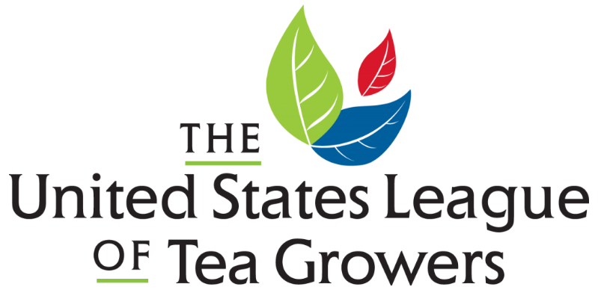

Board Member Application Form

Name:
Email Address:
Phone Number:
Employer/Organization & Job Title (If Any):
Preferred Pronouns:

The US League of Tea Growers (USLTG) is made up of dedicated tea growers, educators, enthusiasts, and retailers and actively encourages the growth and production of high value specialty teas within the USA. We provide education, resources, and support in all facets of your tea growing journey. Our goals are to offer knowledge for specialty tea growing, encourage collaboration between tea growers, promote tea agriculture, recruit academia to teach "best practices" for growers, and represent US tea growers across the globe.
As a 501(c)(6), the USLTG is governed by a Board of Directors. The Board is responsible for ensuring the USLTG fulfills its mission by setting the strategic direction and goals, monitoring operations, and evaluating and supporting the organization’s performance. A Board Member must fulfill the fiduciary responsibilities of the Board of Directors, including making corporate decisions that protect the public interest.

Board Member Responsibilities
Full responsibilities are outlined in the attached document ‘Board Member Job Description.’ Please indicate with your initials that you have reviewed this form.
_____________
Applicant Initials
Instructions
Please answer the questions below. If you would prefer to submit responses via recorded video or a phone interview, please email exec@usltg.org for additional information.
- Why do you believe the work of the US League of Tea Growers is important?

- Why do you want to participate as a Board Member? What do you hope to gain in personal or professional experience from this role?

- What ideas or programs would you like to implement as a Board Member?

- Please describe any tea growing, tea retail, tea research, or other experience that will contribute to your ability to fulfill the Board Member responsibilities.

Optional Information
By providing this information, you will help us ensure that appointments represent a broad cross-spectrum of the community. You are under no obligation to provide this information. State and federal law prohibit the use of this information to discriminate against you. The USLTG will treat this information as confidential.
Gender:
LGBTQ+ Identification:
Ethnicity:
Race:
Age:

